Experiment 4

Experiment 4-A: Reactivity of Metals in a Marine Environment

Objectives

- To measure the potentials of brass and mild steel electrodes in 5% NaCl salt solution.
- To compare between the reactivity of two unknown metals (Zn ,Cu) in a given environment without potential measurements.

Theory

The ease with which metallic materials corrode can be judged by measuring the electrode potential of the corresponding metal in a given environment. Reference electrodes such as SCRE are usually used in measuring electrode potentials .
For a given metal and environment , the lower the value the measured potential , the more active is the metal in this environment . Thus if two unknown metals are immersed in a given environment, connections to the terminals of the voltmeter should be adjusted to give a positive reading . In this case the metal connected to the negative pole of the voltmeter is the anode and the other metal is the cathode.
More details about corrosion and reactivity of metals are covered in your text book in the following sections: 18.1 and 18.2.

Apparatus
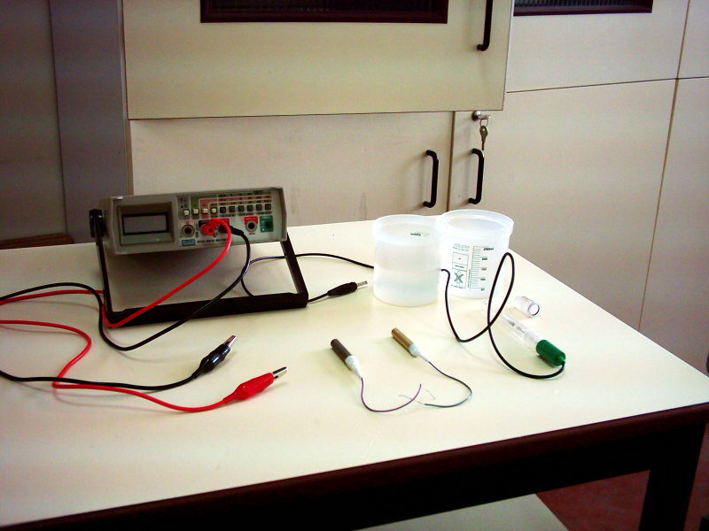
Figure 4A.1 Experimental set up used for potential measurements

- Glass beaker.
- 5% by weight NaCl salt solution.
- Standard Calomel Reference Electrode(SCRE).
- Thermometer.
- Multimeter (set to the voltage measuring mode).
- Crocodile clip ended connecting leads.
- Brass, mild steel and two unknown electrodes (Cu, Zn )

Procedure

- Prepare 5% by weight NaCl salt solution and measure its temperature using the given thermometer.
- Connect the brass and steel electrodes to the connecting leads.
- Immerse the brass and SCRE in the salt solution and connect the multimeter across the two electrodes and read the measured electrodes potential.
- Disconnect the brass electrode and repeat step 3 for steel electrode and read the measured electrode potential.
- Disconnect the steel electrode.
- Connect each of the unknown two electrodes to the connecting leads.
- Immerse both electrodes in the salt solution and connect them to the terminals of the multimeter .

Data analysis

- Compare the measured electrode potentials with their respective standard potentials given in your text book . Explain the difference, if any.
- Rank brass and mild steel according to their measured potentials in 5% NaCl salt solution . Compare your ranking with that given in the galvanic series of your text book .
- For the two unknown metals, notice the sign of the voltage reading and base your judgment of the relative reactivity of each electrode .

Discussion and conclusion

Write a concise account of the experiment and the results obtained .

