Geographic Information System (GIS) Application for camels: Case of Al Ain, UAE

M. M. Yagoub
Department of Geography
Faculty of Humanities and Social Sciences
United Arab Emirates University
P. O. Box 17771, Al-Ain, UAE
E-mail: myagoub@uaeu.ac.ae

URL: http://faculty.uaeu.ac.ae/~myagoub
Abstract
Since 1980s the UAE has witnessed a rapid socio-economic transformation that affected many aspects of life including spatial distribution of camels. In this study factors affecting on camels distribution were modeled using variables such as vegetation, water, veterinary clinics, and racetracks. GIS and spatial analysis were utilized to carry out the modeling process. Results had revealed that camels in the UAE were found clustered near racetracks and roads and not near traditional attractive factors such as sources of water and grazing areas. Such clustering is unique in the UAE in comparison to other countries in the Middle East and North Africa. The causes of this clustering are due to social and economical reasons related to racing. The social factor was found to be the high reputation when one wins a camel race and the economical factor was the high revenues from camel racing (prizes may reach up to US$ 3 million). Through the study the role of GIS was demonstrated to local users, with the key feature that it greatly reduces the amount of time spent in analysis and preparing of maps for camels. This had helped to change people's perception about the capabilities and potential use of GIS for camels.
Key Words: Camels, GIS, UAE

Introduction
In the last few years the UAE had paid a great attention to camels, mainly due to the rise of camel race (Cullen, 1999) and because the camel is a symbol of heritage (Abdalla, 1988; Alami, 1998). The attention is reflected in the establishment of five research centers across the country to carry out researches related to camels and foster relationship with regional and international centers. The UAE had also hosted many conferences and workshops related to camels, for example, the First International Conference on Camels in Dubai in 1992, and the International Meeting on camel production and future perspectives in Al-Ain in 1998. It is very clear that there is a public and governmental support to the conservation of camels. There is a move among GIS specialists for conservation of cultural and natural resources worldwide (http://www.scgis.org), for example, GIS conservation efforts for tigers in the Indian Subcontinent and for elephants in Kenya (ESRI, 2002). This study demonstrates the applicability of GIS for camels as a natural resource in the region.

Objectives
The objective of this study is to explore the possible use of GIS analysis in investigating the spatial relationship between location of camels’ stables and distribution of camels' facilities (interaction of spatial objects). It is assumed that distribution of camels depends on environmental variables such as valleys, roads, water filling stations, veterinary clinics, fodder farms, and racetracks.

Study area
A pilot study is conducted in the eastern region of the UAE (Figure 1). The region is located approximately between latitude 23º 03´ and 24 º 40´ North and Longitude 55º 05´ and 55º 53´ East. The region was selected because of its high density of camels, 84% of camels in the UAE are lived in the region (Abdalla, 1988), availability of some data, and accessibility. In addition to that, the capital city of the region (Al Ain) had been selected by the International Heritage Center (branch of the UNESCO) as a historical site that will host an International workshop soon (Al Ittihad, 2003). The workshop will focuses on using GIS and remote sensing for management of natural and man-made conservation sites.

Problem
Information about camels in the UAE is becoming very important especially after the establishment of Camel Race Federation in 1992. The establishment of the federation had given camel race high reputation and it is directly or indirectly a strong move towards conservation of camels. There is no proper spatial database in the region showing locations of camels' stables in relation to environmental variables such as roads, valleys, racetracks, veterinary clinics, and fodder farms. Such relationship may help in management of camel facilities as well as understanding the socio-economic development the society has passed through. Currently, Al Ain Department of Agriculture and Animal Resources is inspecting the distribution of camels and their facilities using manual overlay of maps. This procedure is subjected to errors, it is time-consuming, tedious, and above that data cannot be reuse efficiently. GIS was considered, to large extent, a suitable tool that can be explored.

Data
A GIS database was built, which included main roads in the region, stables, water filling stations, valleys, fodder farms, veterinary clinics, and racetracks (Table 1). The data was collected from various departments involved in camel activities such as Al Ain Municipality, Al Ain Department of Agriculture and Animal Resources, and the Camel Race Federation. Global Positioning System (GPS) receiver was used to locate camels’ stables. The steps followed in building the GIS database included digitization of geographic data, creating topology, checking feature accuracy and transforming to real-world co-ordinates system, preparing attribute database, and linking geographic data with attribute data (Table 1).

Hardware and Software
The hardware used in this study included PC Pentium IV (RAM 128 MB, HD 15 GB), HP DeskJet 1220C color printer, Genius Vivid III scanner, and SILVA Multi-Navigator GPS receiver. The software used in preparing and analysis of the data included Adobe Photoshop, MS Access, and ArcView 3.2 with Network Analyst.

Analysis
Spatial analysis was used as main method to quantify the relationship between the environmental variables and distribution of camels. Spatial analysis functions such buffering, point-in-polygon, statistical analysis, and network analysis were used extensively throughout the study (Figure 2, 3, and 4). The map in Figure 2 shows buffer of 5 km around racetracks, this buffer zone was used to check the density of camel’s stables near racetracks. The figure also checks for location of camels’ racetracks near the city center. The map in Figure 3 shows buffers zones around roads. These buffers were used to check dangerous racetracks (located close to roads) and accessibility of facilities (fodder farm, water filling station, veterinary clinic). Figure 4 shows spider diagram that depicts the clustering of stables near racetrack and the statistical summary of distances between the racetrack and each stable. Both of Figure 4 and 5 demonstrated the use of remote sensing imageries to enhance visualization of studies related to camels.

Programs were written in Avenue in a form of custom dropdown menus to allow a user to interactively perform the analysis.

Future work
Future work will focus on tracking the movements of camels in a race by deploying a special GPS tracking collars. Positions of camels can then be converted to spread sheet format either as a text (*.txt) or database (*.dbf) and imported into ArcView Tracking Analyst. An Internet-based GIS system that allows camels’ owners to access the database anywhere and at any time using the latest mobile technology (mobile phone accompanied by GPS receiver and Wireless Application Protocol -WAP) is on its way.

Conclusion
The study utilized GIS technology and spatial analysis functions to study the distribution of camels. The camels were found mostly clustered near racetracks roads (Figure 3 and 4). Using GIS for camel analysis proved a very satisfying experience, with benefits accruing with ease of data manipulation, analysis, and display. The lessons learned from this exercise is that spatial analysis can be strengthened by a questionnaire to include a social dimension, and to convince ordinary people about the viability of GIS one has to produce something real (hardcopy maps) beforehand. For greater benefit to locals, Arabic versions of maps were prepared. Through the maps we assisted the local community to know where are the facilities related to their camels and how they can access them through an optimum route, consequently, perform their job more efficiently and manage their resources more economically. The study was faced with numerous problems, particularly in the identification of stables, owing to their location among high sand dunes.

Acknowledgements
The author would like to appreciate the support and cooperation of the ESRI office in the UAE (GISTEC). Thanks are extended to Mike DeLaune, Oregon Department of Forestry for his excellent Xtools developed for ArcView.

References
Abdalla, O. M. (1988). Camels: Breeding, monitoring, and production. Al Ain, UAE: United Arab Emirates University Press (In Arabic).
Alami, J. (1998). Camels in the United Arab Emirates: Historical, cultural, and field study. Abu Dhabi: Camel Race Press (In Arabic).
Al Ittihad, 2003. Al Ain Hosting an International Workshop on Management of Heritage Information. Al Ittihad News Paper, Wednesday, January 15, 2003.
Cullen, M. (1999). Lulu: Queen of the Camels. The Atlantic Monthly 284 (4):72-82.
ESRI, (2002). African Elephants Cause Aided by GIS Community. ARCNEWS 24 (3): 1.

Web sites (Accessed on January 26, 2003)
ESRI (ArcView Scripts and Extensions): http://www.esri.com
GIS conservation efforts: http://www.scgis.org

Table 1: Attribute of camels ' facilities.
Geographic feature | Attribute
Racetrack | Name, date of establishment, area, number of workers, percentage of greenery, capacity for spectators, availability of VIP hall and Helicopter landing area, facilities (veterinary clinic, restaurant, toilets, mosque, shop, public telephone, number of large screen displays, parking area).
Stable | Name of owner, area, number of camels, main use of camels (milk, meat, race), number of workers, facilities (room for workers, shelter for camels, store for fodder, water tank, car allocated to the stable).
Veterinary clinic | Name, district, date of establishment, number of doctors and workers, type of services (surgery, medicine only), number of cases treated in each year, number of emergency cars (ambulances).
Fodder farm | Name of owner, area, cultivated area, productivity (ton), productivity/square meter, number of wells, type of irrigation (dripping, sprinkling), type of soil, type of fertilizers (potassium nitrate, organic, sulphate), type of fodder (Alfalfa, Rhodes), average elevation.

Figure 1: Location of study area.
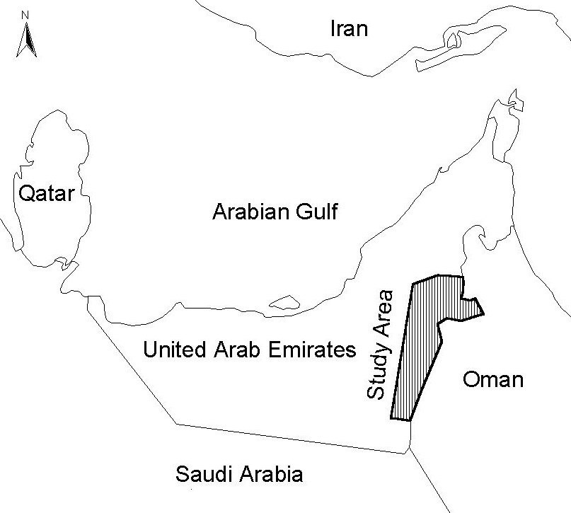
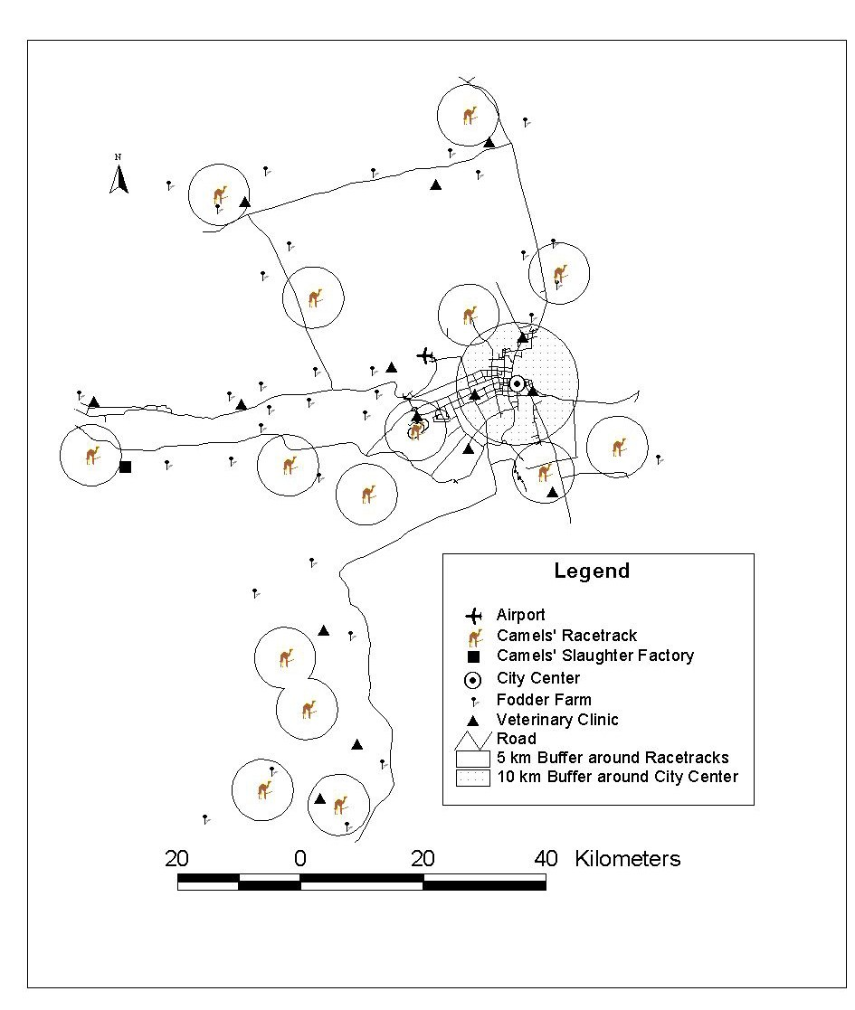
Figure 2: Buffers around racetracks and city center.
Figure 3: Buffers around roads.
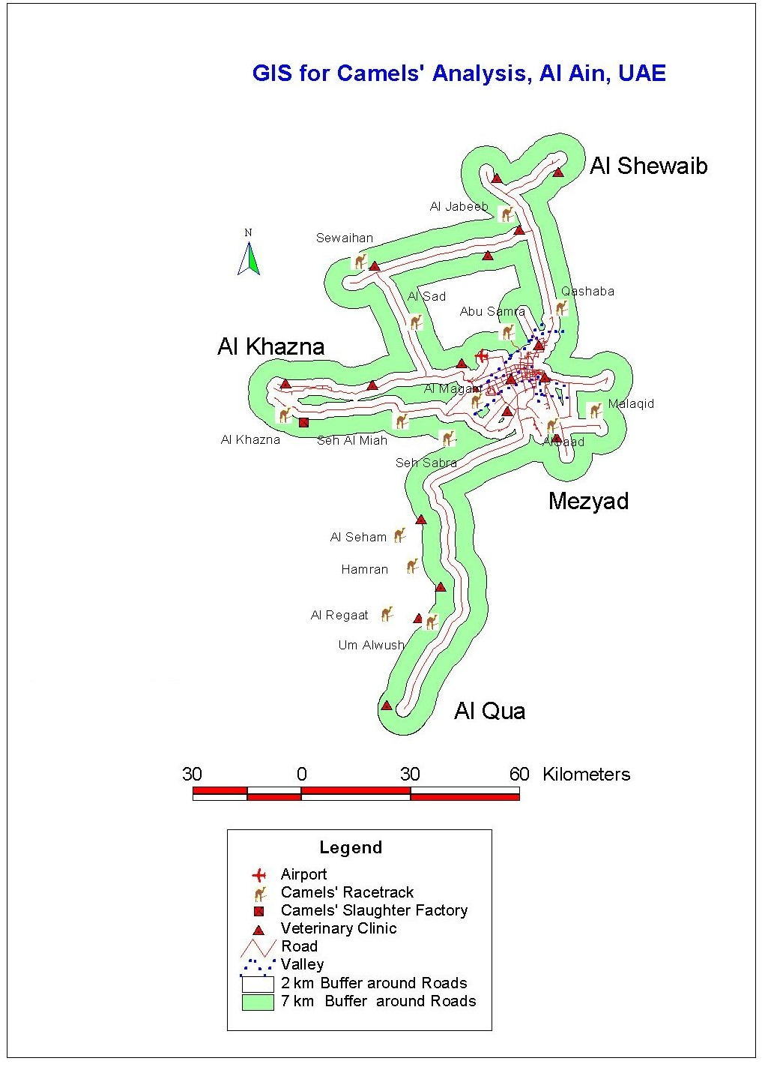
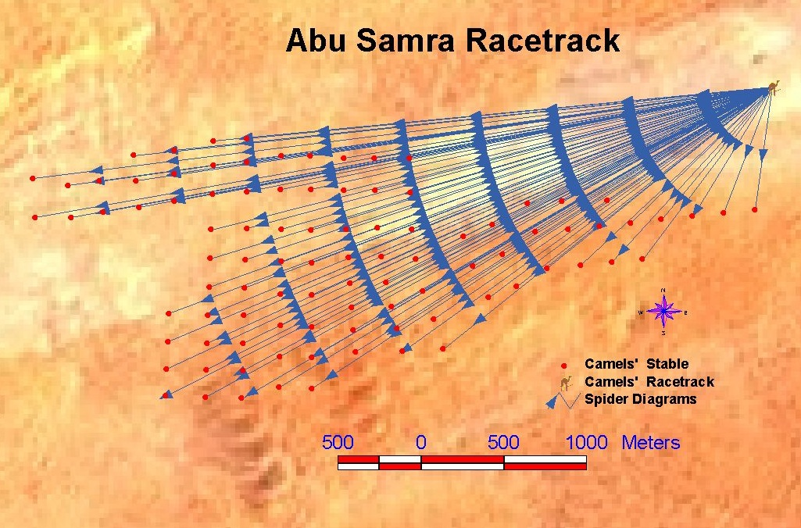
Figure 4: Spider diagram showing the clustering of stables near Abu Samra racetrack and the distance between the racetrack and each stable.

Note: The statistical summary indicated that the minimum, maximum, and mean distance between the racetrack and each stable is 746, 4514, and 2872 meter, respectively.
Landsat TM of 2000 had been used as a background (note the location of stables inside the desert).

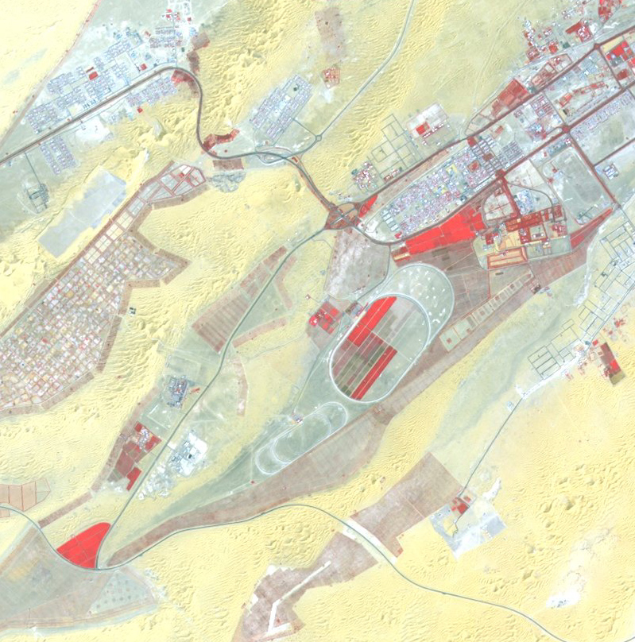
Figure 5: SPOT satellite image (1994) showing the shape of Al Maqam camels’ Racetracks (two ovals at the center of the image). and the distance between the racetrack and each stable.

Al Maqam Palace
Al Maqam Racetracks
Al Selimat
To Al Ain Airport
N
To Abu Dhabi

