GIS1-Lab
Department of Geography
Instructor: Mohsin A. Abbasi

Exercise4: Working with Geographic features-Selecting Features geographically, making new layers, summary statistics and graphs.

Open the data given in GIS the lab in ArcMap.
The data looks as below:

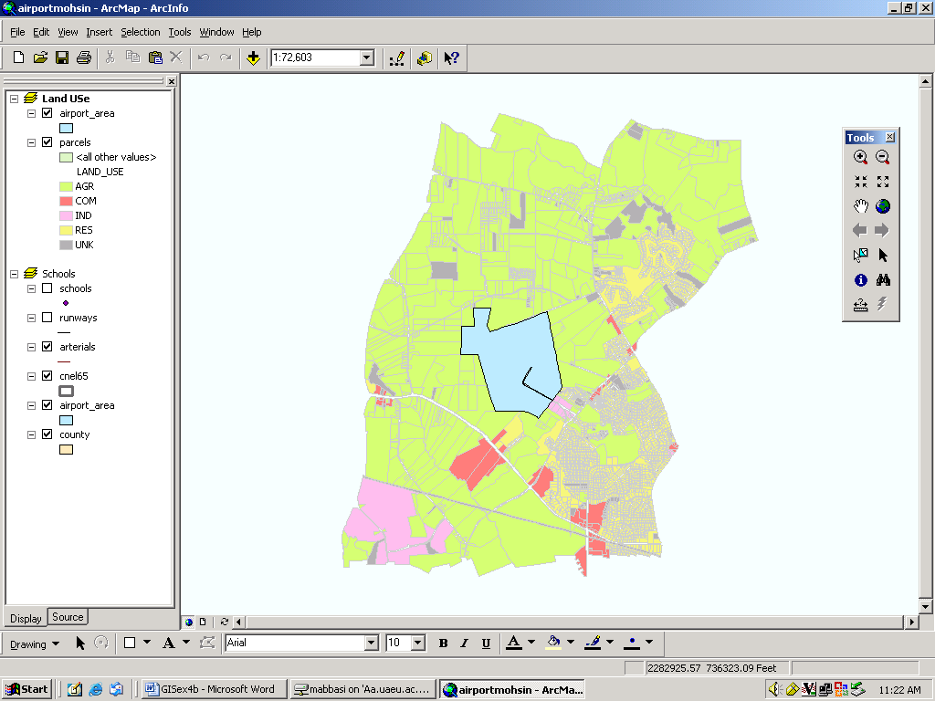

Selecting Features geographically
To find out how much of land use is within the airport area,
Click Select By from tool menu and click Select By Location as shown below:
Select by Location tool will open as shown below:

- In the first box, click the dropdown arrow and click select features from as shown above.
- In the second box check parcels as the layers to select features from as shown above.
- Click the dropdown arrow for the third box and click intersect. This will select the features in the parcels that intersect the airport area features.
- Click Apply and close the box. The selected parcels are outlined in a thick line as shown below
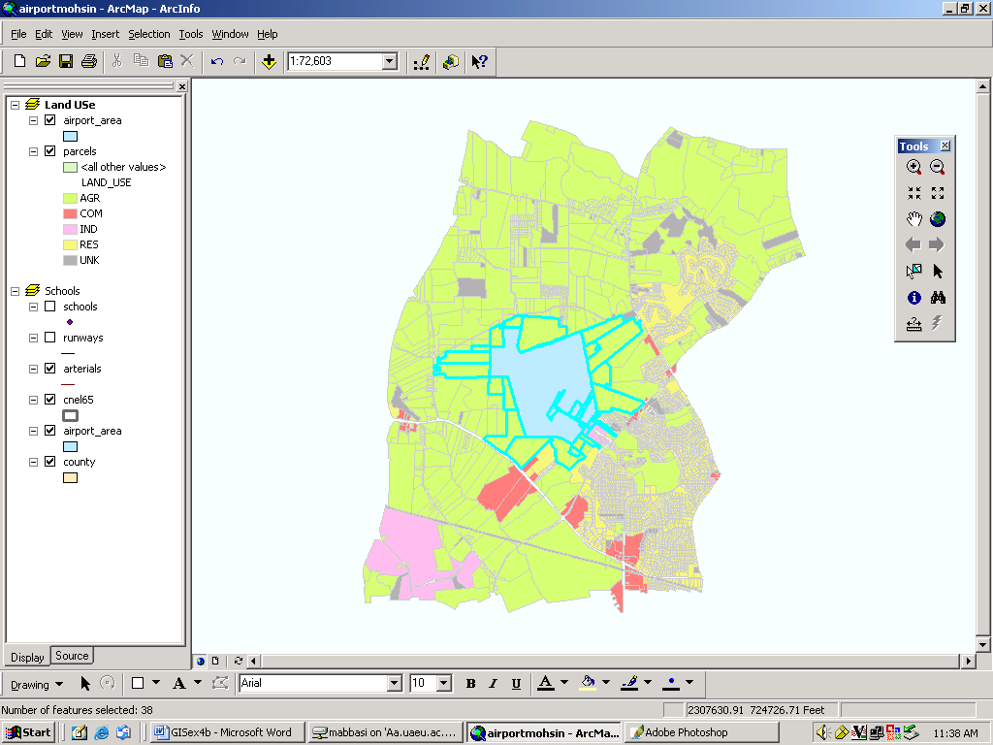

Exporting a layer
To find out how many parcels and how much land area of each land use are within airport area, you will create a new feature class and run statistics on its data table.
- Right click the parcels in the table of contents, point to data and then click Export Data as shown below
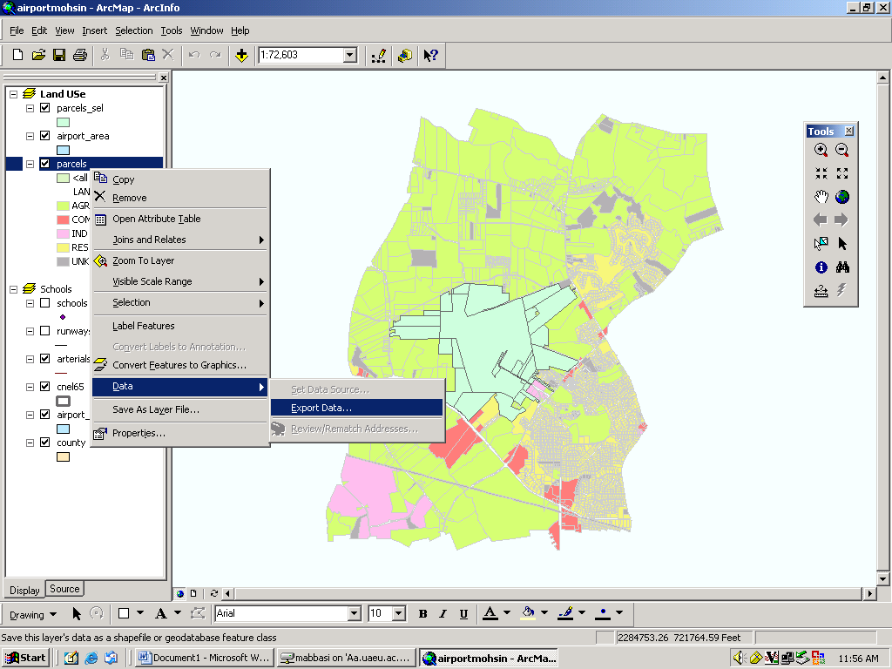

- In the export dialog box, click the Export dropdown arrow and click Select Feature and save the feature as parcelnew as shown below
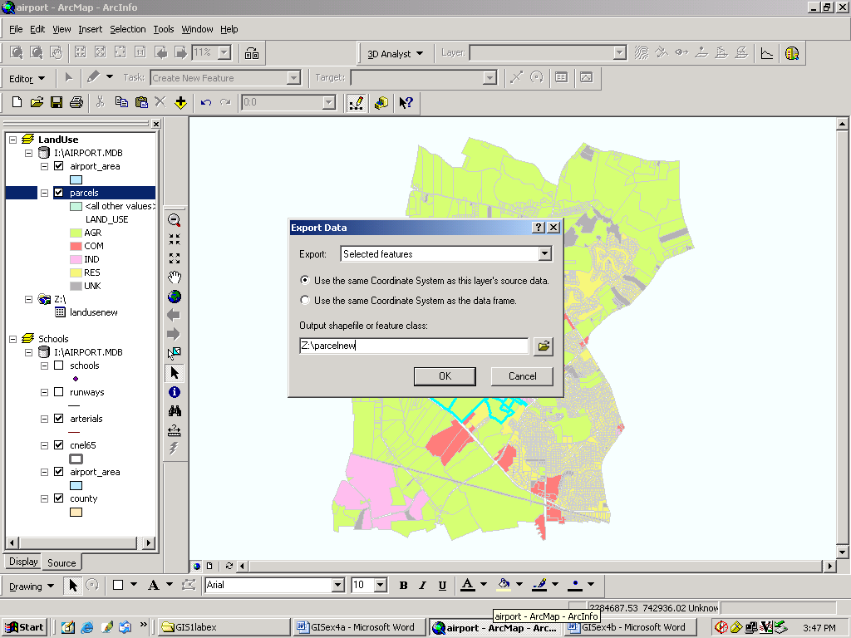
- Click OK. ArcMap exports the parcels to a new feature class in your drive where you have saved it.
- Click Yes when prompted to add the exported data as a new layer on the map. The new layer contains only the selected parcels.
- To clear the selected features go to Selection/Clear Selected Feature.

The new layer is displayed on the top of the other layers.

Creating a Summary Statistics
ArcMap includes tools for statistical analysis. You will create a tool to summarize the number of parcels of each land use type within airport area.
In the table of contents right click the parcelsnew layer you just created and click Open Attribute Table as shown below
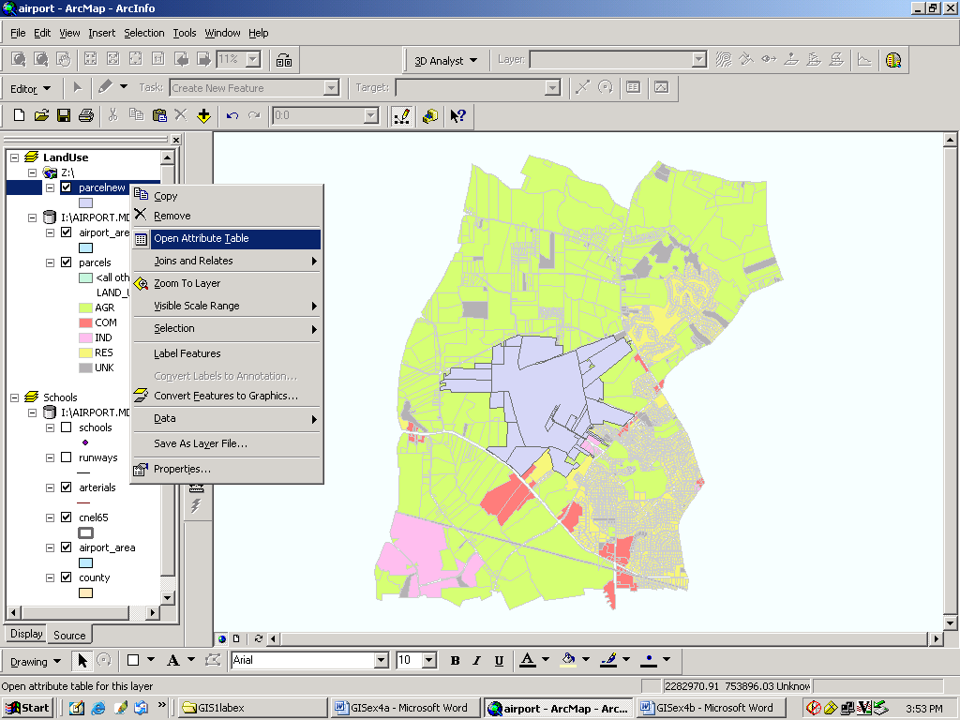

The attribute table will open as shown below
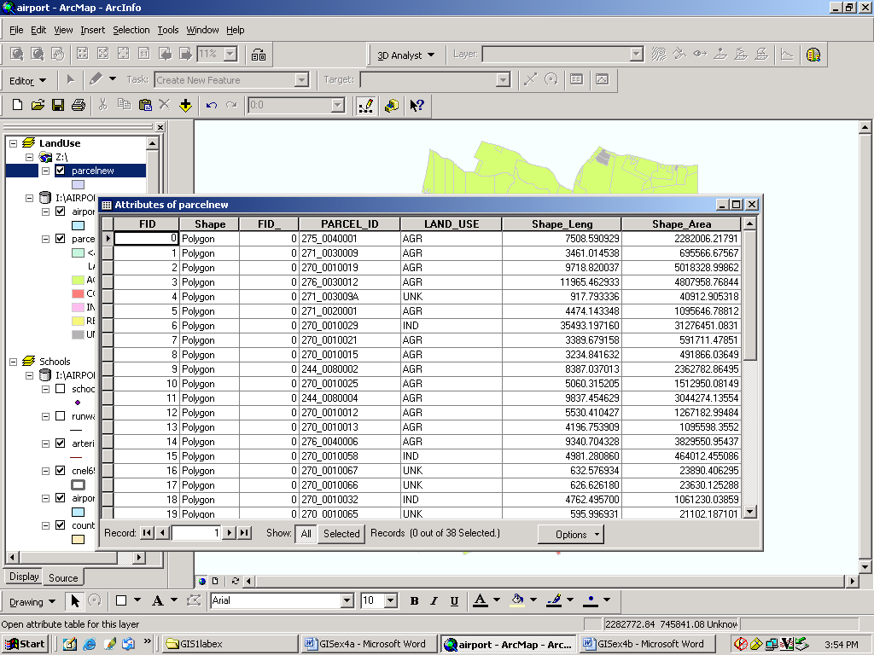
Right click the Land_Use field header and click Summarize as shown below
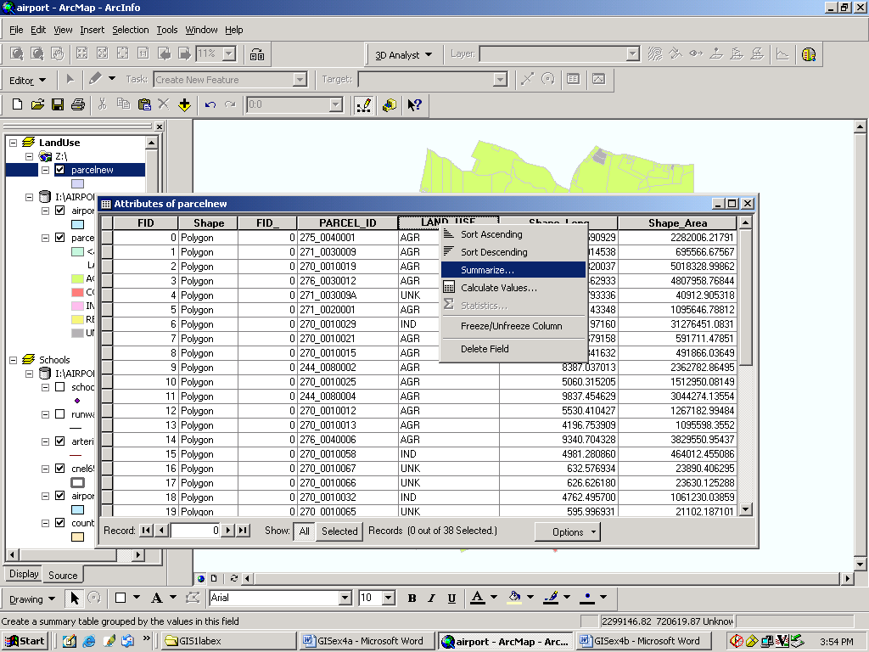

Summarize dialog box opens as shown below:
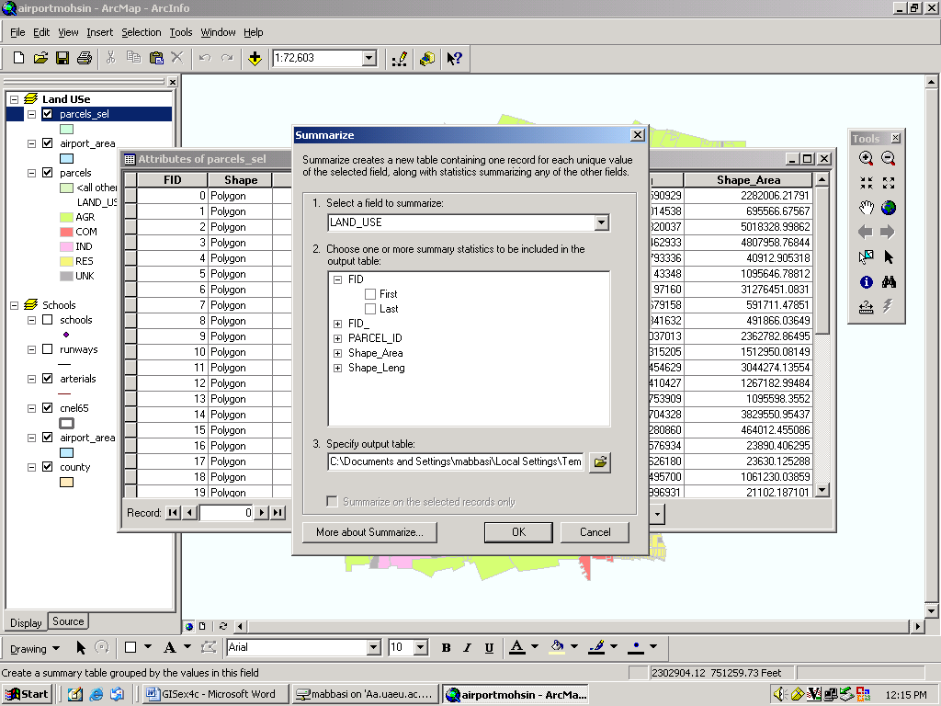

Click the plus sign next to shape_area and click Sum. Then specify as landuse_new, your output table to the path where you want to save this table for example in z drive as shown below
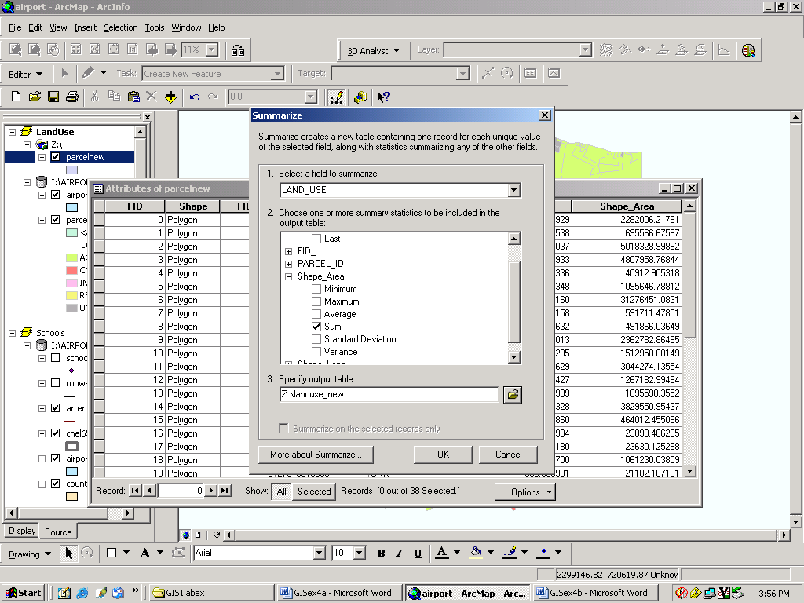

Click OK. landuse_new is added to the table of contents.
Right click the landuse_new table in the table of contents and click open. You can see the number of parcels and total area as shown below
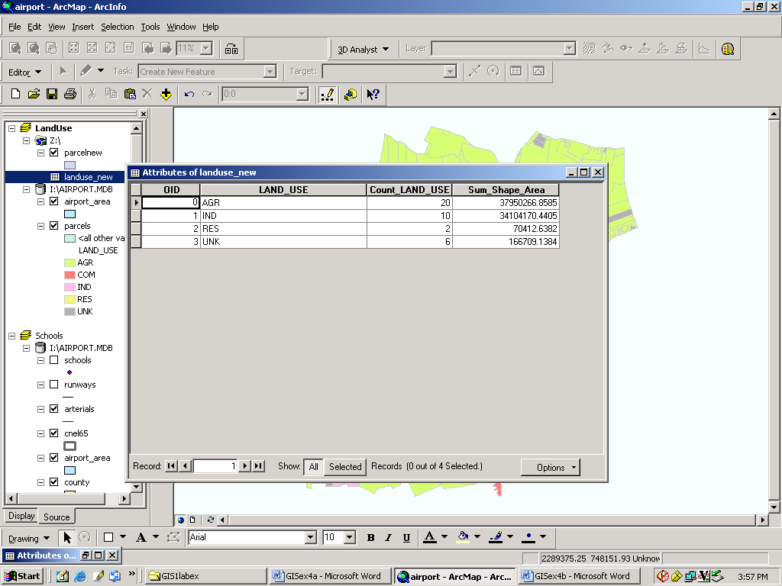
Making a graph

Now you will create a column graph showing number of parcels of each land use type.
- Click the Tools menu, point to the graphs, and click create as shown below:

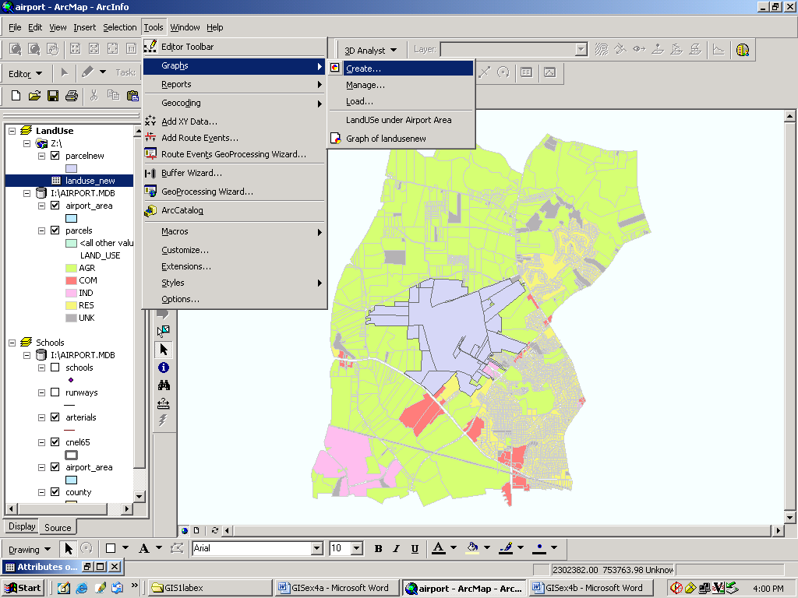

Graph wizard will open. On that click column graph as shown below
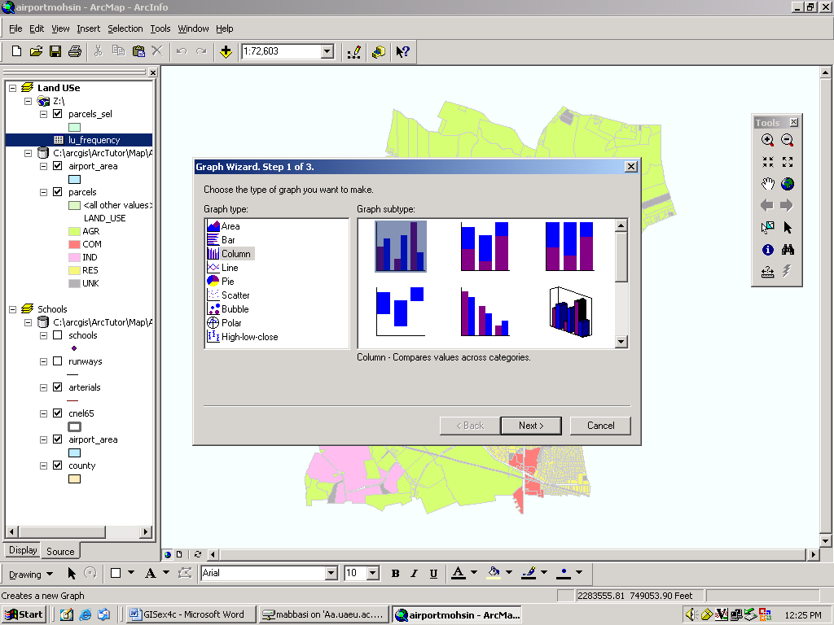

- Click Next.
- Click landuse_new as the table containing the data from the dropdown menu.
- Make sure that Use selected set record is not checked.
- Check the field Cnt_land_use as the field to graph as shown below

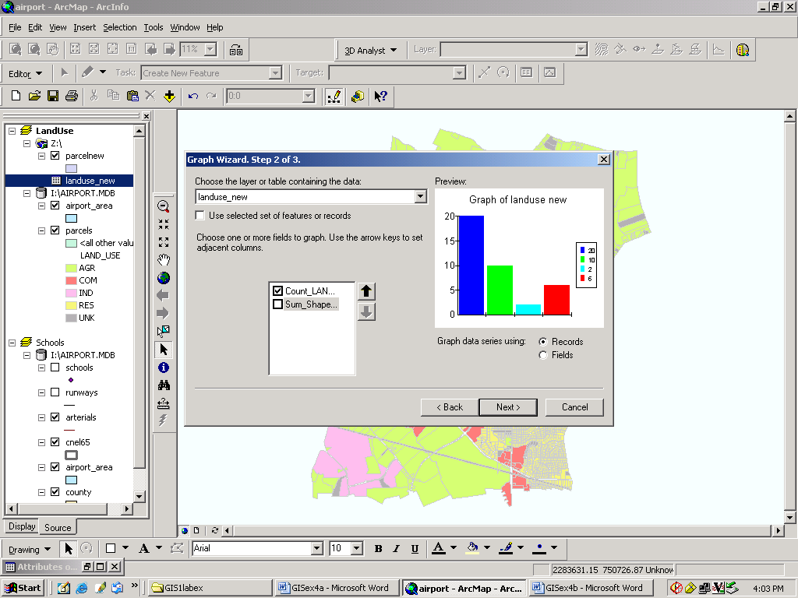
- Click Next
- Check label X axis with: Land_use on the dropdown menu
- Check Show Legend and Click Finish as shown below
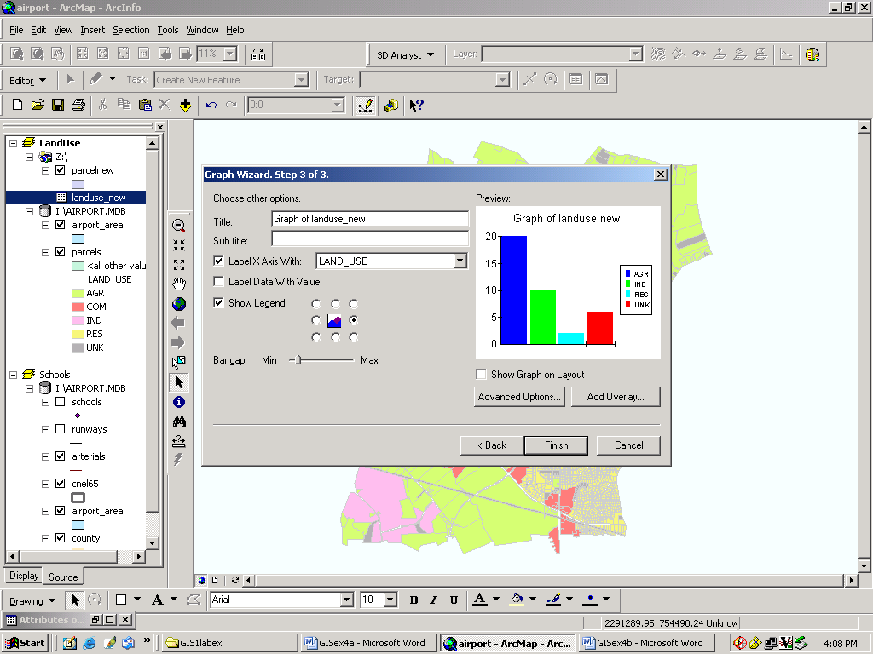
.
The graph appears on the map with the legend. This graph shows land-use in the airport area.

End of Exercise

