GIS1 Lab
Department of Geography & Urban Planning

Instructor: Mohsin A. Abbasi

Exercise3: Symbolizing, labeling and classifying features
Objective of this exercise is to use different symbols, change them by increasing and decreasing their size and also doing classification.

- Open ArcMap from Start/Program file/ArcGIS and add the data of the which you have downloaded from the blackboard.
- ArcMap opens African countries and cities.
- Changing Symbols: Right click on cities in table of content and go to properties. Double click the symbol and choose the symbol from the window. Then click OK.
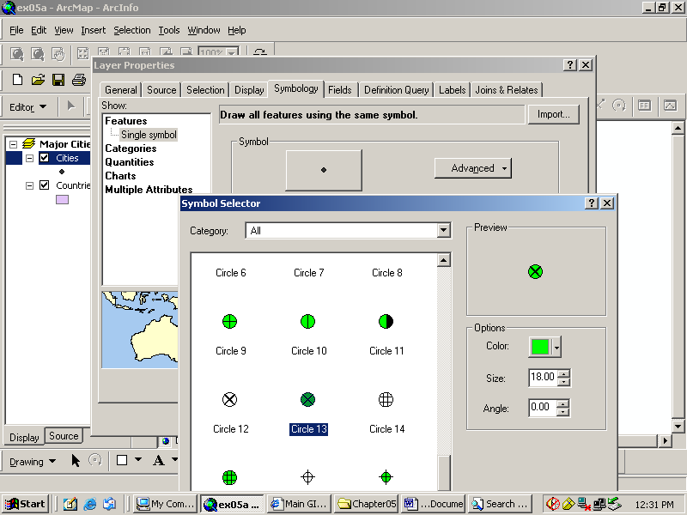

- The symbol in the table of contents is changed. Color and size of the symbol can also be changed in same way.

- Change the color and size of the symbol to see the difference.

- Labeling the features: Now label the cities in display area. This you can do by right click on the cities and go to properties. Click properties and then click labels as shown below
. 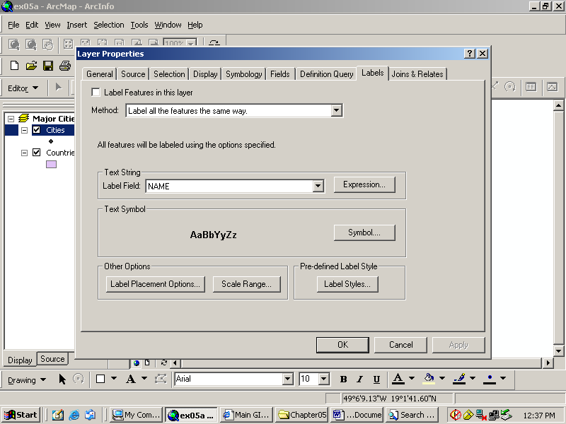
- Click on “label features in this layer” on top. And in text string click name. You can see the labels of the cities are marked in the map as below.
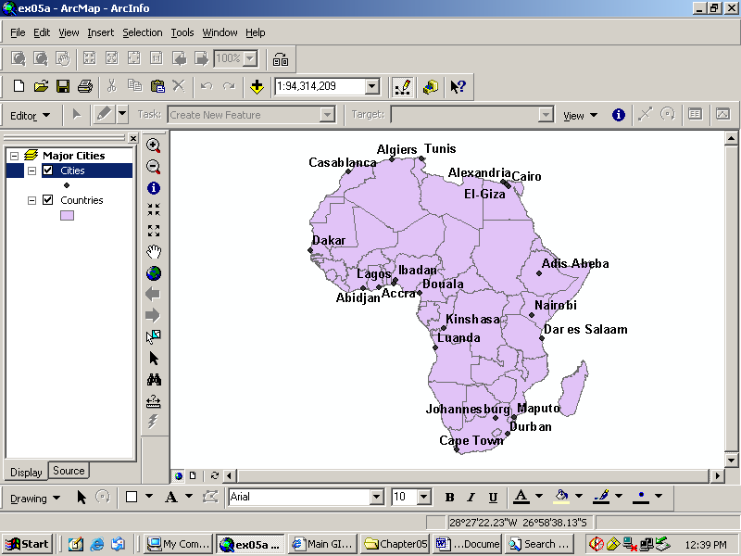

- Changing Background Color: You can change the color of the background of Africa map. Right click on major cities in table of content and click properties in it.
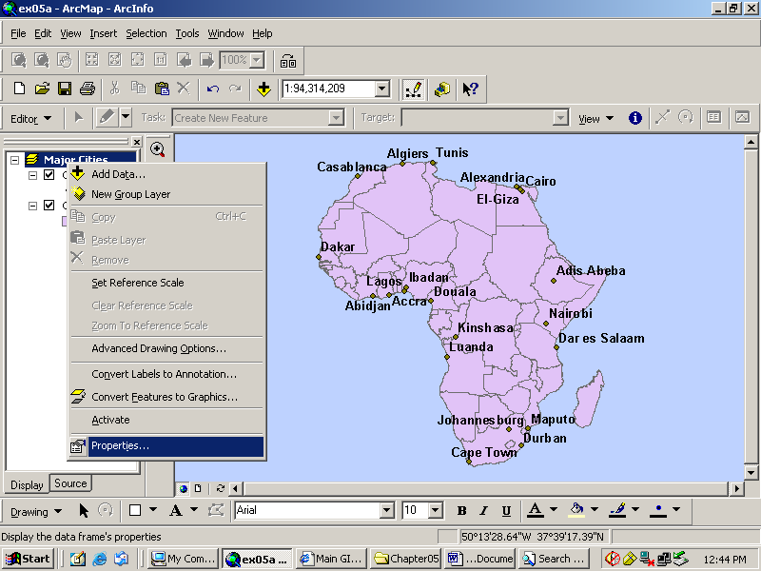
- Click “Frame” from top and go to Background dropdown menu. Select the color blue and click OK. You can see the background is changed to blue as above.
- Classification: Right click on countries in table of content and go to properties. When properties dialog box opens go to symbology. Click categories on left and select Unique Value as shown below.
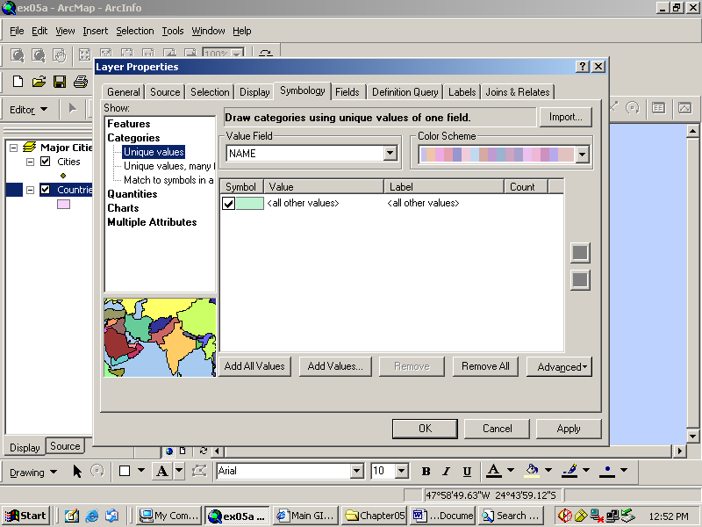

- In the value dropdown menu click “Name” and then click add value in the bottom and select all the countries as shown below:
. 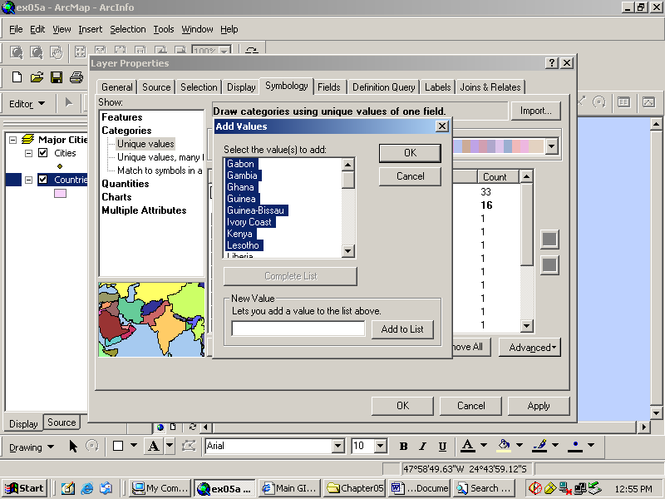

- Click OK. Then click OK in the properties dialog box. You can see in the table of contents that all countries are classified into different colors. You can also change the color each country by double click on the color.

End of exercise.

