GIS1-Lab
Department of Geography
Instructor: Mohsin A. Abbasi

Exercise5: Querying the Data
This exercise is designed to train you how to retrieve unseen information and how you can make hyperlinks.

You have to find a suitable property according to the following criteria:
1. In the neighborhood of ESRI campus (Redland, California)
2. Three bedroom house
3. Located on a corner lot
4. Cost is up to $175000

Identifying, selecting, finding, and hyperlinking features

- Start ArcMap and open ex5.mxd given in the lab.
- Right click on neighborhood parcels and click zoom to layer
- Use identify tool and click one parcel that is for sale and examine the identify results.
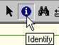

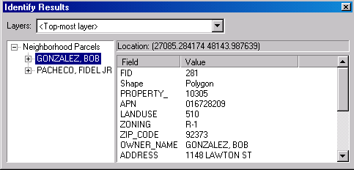

- Close the Identity dialog box.
- Click the Selection menu and click Set Selectable Layers to uncheck the Streets and Other Parcels layers as shown below:

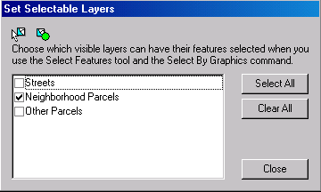

- Click the Selection Options dialog and set the selection tolerance to 0 pixels in order to ensure that when you click on a location you won’t select more than one feature.
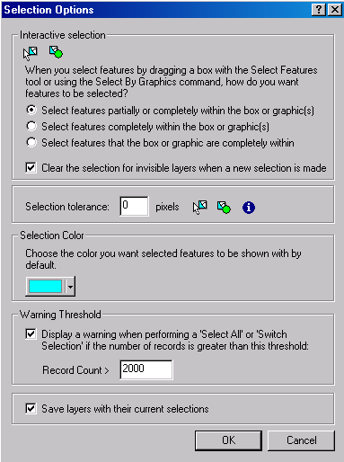

- Click the Select Features tool and select the eight corner parcels that are for sale as shown below:
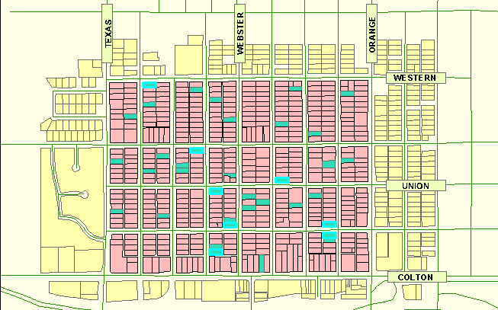

- Right click Neighbourhood Parcels and click Open Attribute Table. At the Bottom of the table click "Selected" button to show only the selected records.
- Right-click on the SALE_PRICE field and click Sort Descending

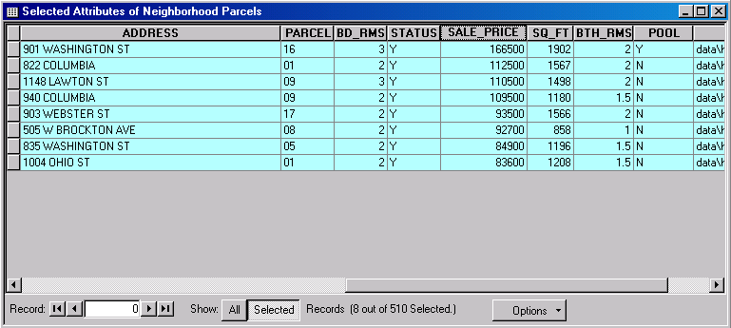

- Click the gray tab to the left of the first record. The record is highlighted in yellow in the table and on the map.
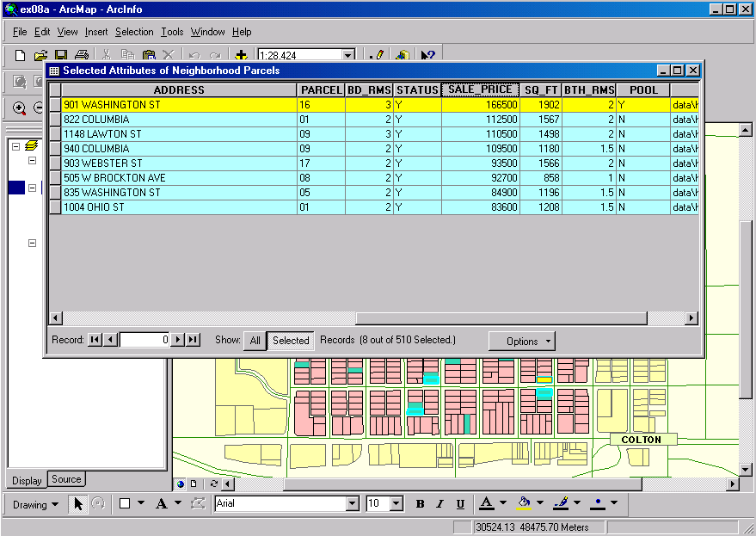

- Close the attribute table and click Clear Selected Features from the Selection menu

HyperLink
- Double-click Neighbourhood Parcels and select Display. Check Support Hyperlinks using field. Select Image from the drop-down arrow.

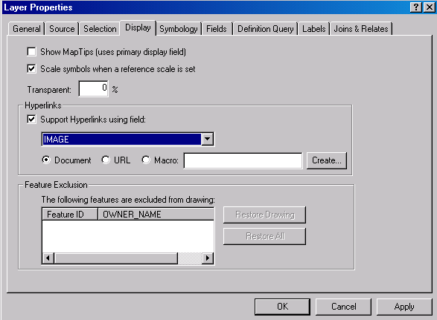

Add a new field with the name of Image. Hint: Right click on neighbourhood parcel layer in table of contents/Open attribute table/Options/ Add field.

Once the Image field is added give the path name as for example (d:\Data\house1.jpg) in Image field. Hint: Images are in Data folder given in the lab. It will be as shown below:
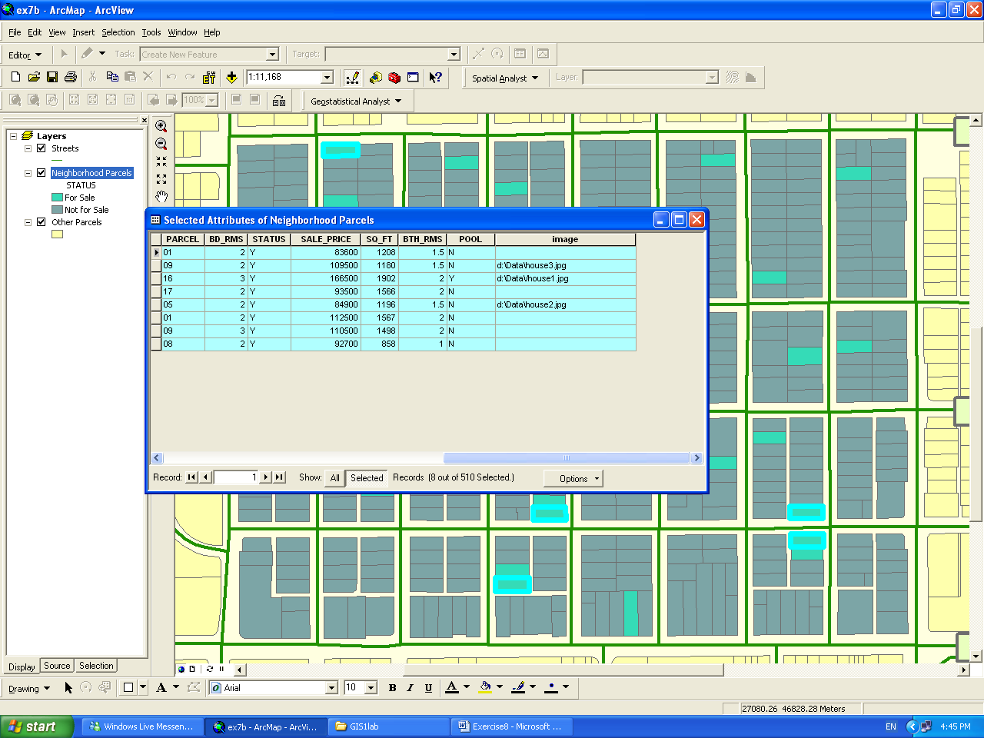

- Click the Hyperlink tool. On the map, hyperlinked features are outlined in blue.
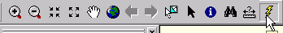

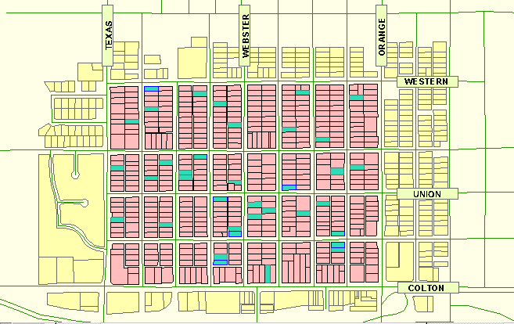

- Click any hyperlinked feature to display a photo of the property

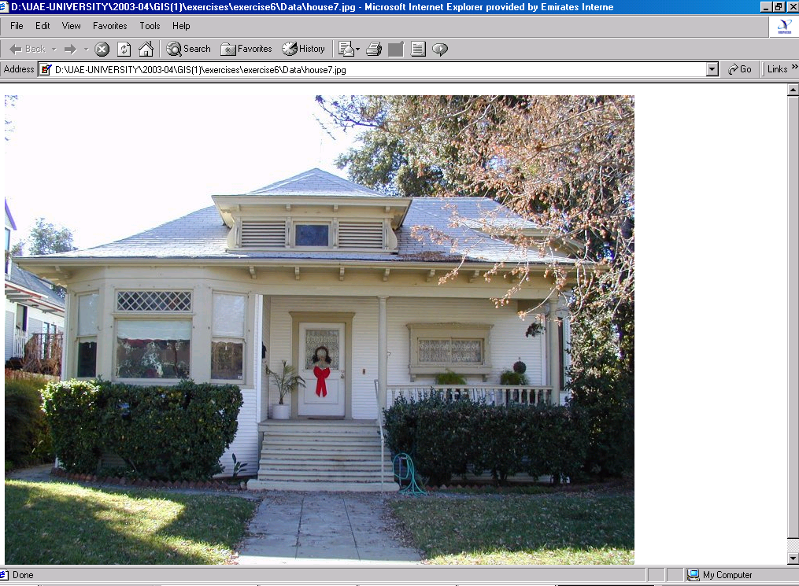

Finding Features
On the Tools toolbar, click the find tool to open the Find dialog

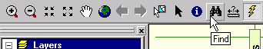

- Type ‘831 Washington St’ in Find dialog and select Neighbourhood Parcels in the layer drop-down arrow.
- In the search options, click in fields and select ADRESS from the drop-down arrow. Then click ‘Find’.
- The matched record will be displayed
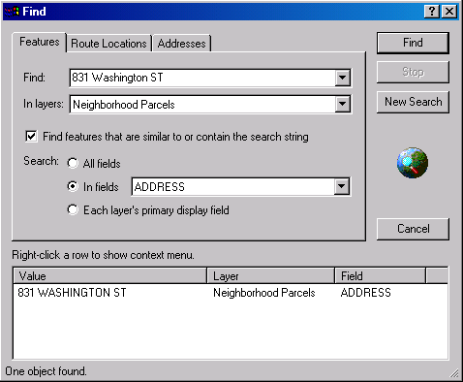

- The matched feature can be located on the map.
- Right click and select Identify feature(s) to display the attributes of that property. Examine the attributes of the property.

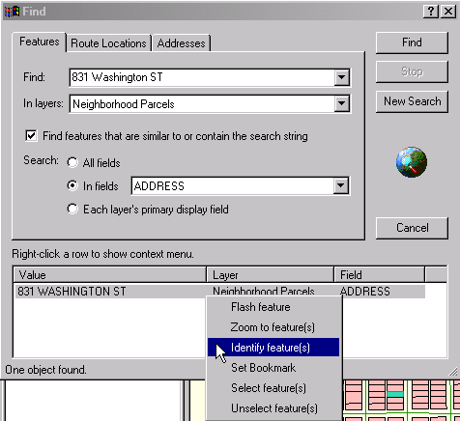

Selecting features by attributes

Queries are written in Structured Query Language (SQL)

- Click the Selection menu and click Select by Attributes. In the Select by Attribute dialog, click the layer drop-down arrow and click the Neighbourhood Parcels.
- Write the first condition ‘Houses for sale have a STATUS of Y’ and click Apply
- The corresponding features will be selected on the map.

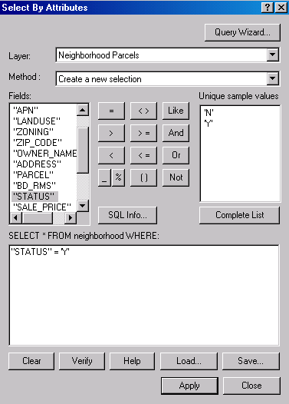

- Apply the second condition ‘ only three-bedroom houses’ by typing BD_RMS=3.
- Add one more condition ‘SALE_PRICE <175000’ by typing
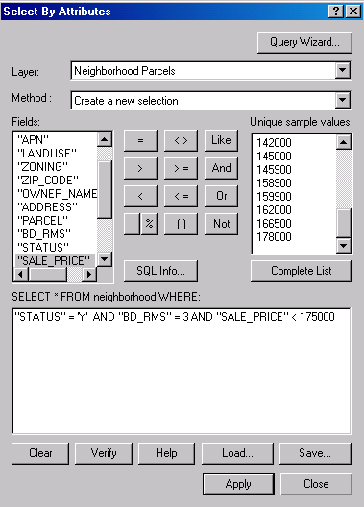

- Eleven parcels are selected
- Click no if asks to save.

End of Exercise

