How to Design a Poster

**Suggested Guidelines for the 13th Annual Nutrition and Child Health Workshop**

A poster can be used to present information. The difference between a **poster** and an **oral** **presentation** is that you should let your poster do most of the ‘talking’; that is the material presented should convey the essence of your message. Your task as the presenter is to answer questions and provide further details and to convince others that what you have done is excellent and worthwhile.

**Suggested format of the poster**

**Design**

**Title**- Include the title and the names of the people involved in the project/evaluation and their affiliation.

**Summary/ Abstract-** State the key findings and the main results.

**Introduction-** Background information and the project aims and objectives.

**Method or Theory-** Explain any theory or procedure you used for the project or evaluation.

**Results-** Give examples of the main results of the work.

**Conclusion-** List the main findings of your project evaluation recommendations and thoughts about how the work could be progressed; other tests that could be applied, etc.

Posters should be designed so that readers leave with the impression that they have learnt something new. The message should be clear and understandable without oral explanation.

1. **Keep the material simple**
   * Do not fill up the entire poster with content. Leave white space.
   * Be selective when showing results. Present only those that illustrate the main findings of the project. However, do keep other results handy so that you may refer to them if asked
   * Minimize detail and try to use simple language
   * Use as few words as possible
2. **Use colors sparingly and with taste**
   * Colors should be used only to emphasize, differentiate and to add interest. Pastel shades convey feelings of serenity and calm while dark bright colors conjure images of conflict and disharmony
   * Choose background and foreground color combinations that have high contrast and complement each other - black or dark blue on white or very light grey is good.
   * It is better to keep the background light as people are used to it (for example newspapers and books).
3. **Do not use more than 2 font types**
   * Too many font types distracts, especially when they appear on the same sentence.
   * Use fonts that are easy on the eyes such as Times New Roman and Arial.   
       
     This is Times New Roman  
       
     This is **Arial**
4. **Titles** and **headings** should appear larger than other text, but not too large. All the text on the poster should be legible from a distance of about four feet away.
5. **Do not use all UPPER CASE type in your posters**. It can make the material difficult to read. Just compare the two sentences below:

WHAT DO YOU THINK OF THIS LINE WHERE ALL THE CHARACTERS ARE IN UPPER CASE?  
  
What do you think of this line, where only the first character of the first word is in upper case?

1. Use underlined text, the **bold face** or *italics* or ***combinations*** to emphasize words and phrases.
2. **A picture is worth a thousand words** 
   * **Use graphs**
     + Choose graphs types that are appropriate to the information that you want to display.
     + Use contrasting coloredlines or different line styles to give your graphs contrast.
     + Label graphs.
     + Graphs should be able to be read from 4’ away.
   * **Use diagrams and drawings**
     + All diagrams and drawings should be labeled so people know what they are looking at.
     + Do not try to cramp labeling to fit into components of a drawing or diagram.
     + Graphs should be able to be read from 4’ away.
3. **Check your spelling**
   * Spelling mistakes give the impression that you are careless.
4. **Maintain a consis****tent style** 
   * Inconsistent styles give the impression of disharmony and can interrupt the fluency and flow of your messages.
   * Headings on the different parts of the poster should appear in the same position
   * Graphs should be of the same size and scale especially if they are to be compared.
   * If bold lettering is used for emphasis on one part, then do not use italics on others.
   * Captions for graphs, drawings and tables should either be positioned at the top or at the bottom of the figure. Pick one position and use it for the entire poster.
5. **Arrangement of poster components should appear smooth** 
   * Remember that you are using the poster to tell a story about what you have done and achieved. As in report writing, the way you arrange the sections should follow the 'storyline.'
   * The movement (pathway) of the eye over the poster should be natural- down the columns or along the rows.
   * The figures and table should cover slightly more than 50% of the poster area. If you have only a few illustrations, make them large.
   * It is advisable to prepare sections of the poster on paper before sticking them onto mounting boards or display stands. Enlarge your best initial sketch, keeping the dimensions in proportion to the final poster. Ideally, the rough layout should be full size. A wipe board is a convenient place to work. Print the title and headlines. Indicate text by horizontal lines. Draw rough graphs and tables. This will give you a good idea of proportions and balance.
   * The movement (pathway) of the eye over the poster should be natural- down the columns or along the rows.
6. **Review, review and review**
   * Make draft versions of your poster sections and check them for
     + mistakes
     + legibility and
     + [inconsistency in style](http://lorien.ncl.ac.uk/ming/Dept/Tips/present/posters.htm#style#style)
   * Try different layout arrangements.
   * Ask your partner, friends, colleagues or supervisor for their 'honest' opinions.
   * Be critical. Now ask, is the message clear? So the important points stand out? Is there a balance between words and illustrations? Is there spatial balance? Is the pathway through the poster clear?

**You can use a single PowerPoint slide to design your poster.**

Sample Poster Arrangements

The following three images are sample layouts for your poster presentation.

*EXAMPLE #1:*  
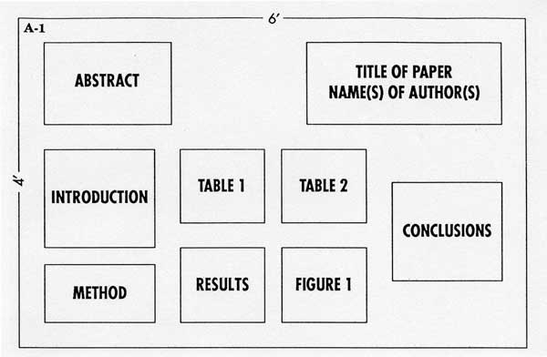

*EXAMPLE #2:*  
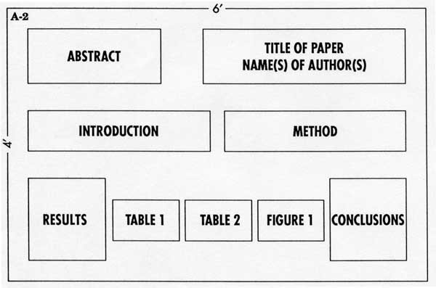

*EXAMPLE #3:*  
